CHAPTER 1 Multivariate Linear Time Series

library(MTS)  
library(mvtnorm)

sig=diag(2) #create the 2-by-2 identity matrix

x=rmvnorm(300,rep(0,2),sig) #generate random draws

colnames(x) <- c("Serie 1", "Serie 2")  
MTSplot(x) # Obtain time series plots (output not shown)

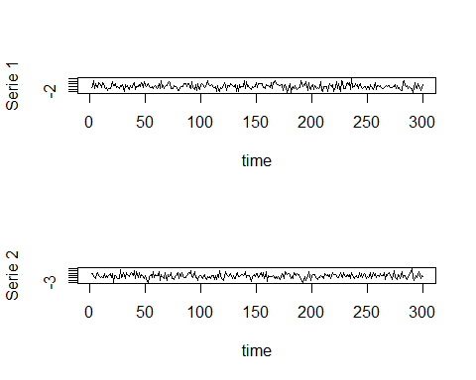

ccm(x)

## [1] "Covariance matrix:"  
## Serie 1 Serie 2  
## Serie 1 0.9963 -0.0313  
## Serie 2 -0.0313 1.0580  
## CCM at lag: 0   
## [,1] [,2]  
## [1,] 1.0000 -0.0305  
## [2,] -0.0305 1.0000  
## Simplified matrix:   
## CCM at lag: 1   
## . -   
## . .   
## CCM at lag: 2   
## . .   
## . .   
## CCM at lag: 3   
## + .   
## . .   
## CCM at lag: 4   
## . .   
## . .   
## CCM at lag: 5   
## . .   
## . .   
## CCM at lag: 6   
## . .   
## . .   
## CCM at lag: 7   
## . .   
## . .   
## CCM at lag: 8   
## . .   
## . .   
## CCM at lag: 9   
## . .   
## . .   
## CCM at lag: 10   
## . .   
## . .   
## CCM at lag: 11   
## . .   
## . .   
## CCM at lag: 12   
## . .   
## . .

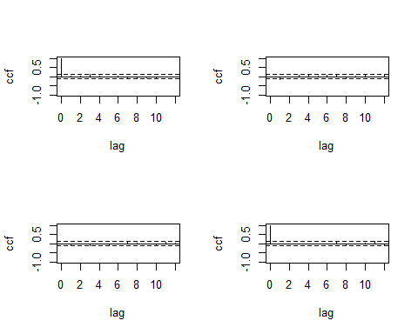

## Hit Enter for p-value plot of individual ccm:

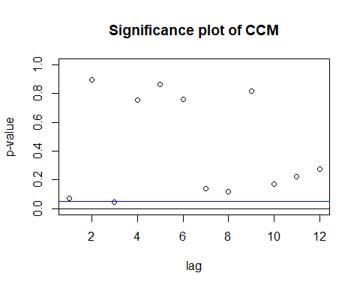

# Prueba Ljung-Box  
# Ho: Los datos se distribuyen de forma independiente la correclacion de los datos es 0.  
# Ha: Los datos no se distribuyen de forma independiente.  
  
LB <- mq(x, lag = 10)

## Ljung-Box Statistics:   
## m Q(m) df p-value  
## [1,] 1.00 8.58 4.00 0.07  
## [2,] 2.00 9.69 8.00 0.29  
## [3,] 3.00 19.56 12.00 0.08  
## [4,] 4.00 21.48 16.00 0.16  
## [5,] 5.00 22.77 20.00 0.30  
## [6,] 6.00 24.65 24.00 0.42  
## [7,] 7.00 31.65 28.00 0.29  
## [8,] 8.00 39.07 32.00 0.18  
## [9,] 9.00 40.63 36.00 0.27  
## [10,] 10.00 47.03 40.00 0.21

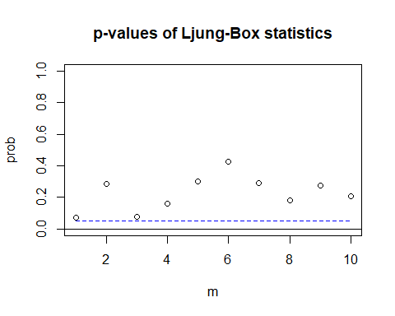

plot(x[,1],main = "Prueba gráfica de raíz unitaria", xlab = "Tiempo", ylab="Serie 1", type = "l")  
abline(h = c(0,1.95, -2.2), col = c("darkgreen", "blue", "blue"),  
 lty = c(1,2, 2), lwd = c(1,1, 1))

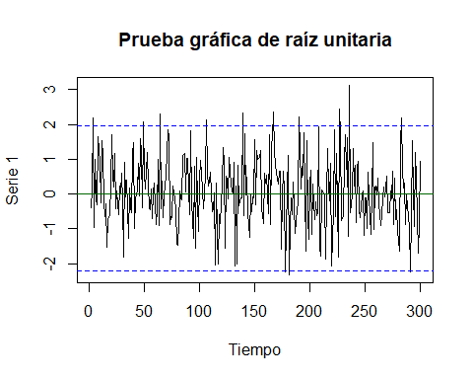

$$H_{0}: ρ = 1 y H_{a}: ρ < 1$$